
Application Form
May 10 - 13, 2016 l KINTEX l KOREA


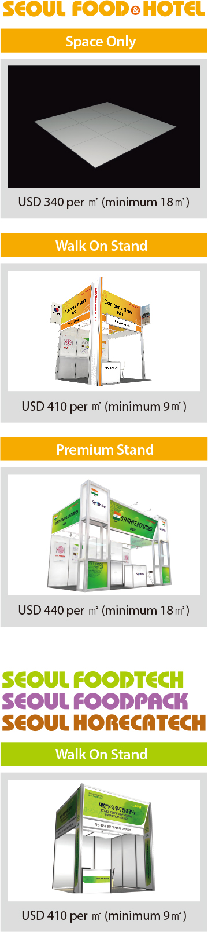

I would like to exhibit the following:

Stand Type | Stand Type
  □ Space Only (minimum 18m²) | US$340/㎡
  □ 3m x 3m | □ 3m x 6m
  □ Walk On Stand  (minimum 9m²) | US$410/㎡
  □ 3m x 9m | □ 6m x 6m
  □ Premium Stand  (minimum 18m²) | US$440/㎡
  □ 6m x 9m | □ ......m x ......m

*Please note that Premium Stand is only available at SEOUL FOOD&HOTEL.
*Please note that completion of this form constitutes no commitment of any kind.

Your Details
Please attach your business card or complete your details below:

Company:
Name:
Job Title:
Address:

Country:
Tel:
Fax:
E-mail:
Website:
Products:
Date:


Strategic Exhibition Team
13, Heolleungno, Seocho-gu, Seoul, 137-749 KOREA
Tel: +82-3460-7266 l Fax: +82-3460-7958
E-mail: 915445@kotra.or.kr l www.seoulfood.or.kr

