Web: www.destinationfestival.ba  E-mail: destinationfestival@skenderija.ba  Tel: +387 33 201-183  Terezija bb, 71 000 Sarajevo, BiH  KJP Centar ”Skenderija” Sarajevo | 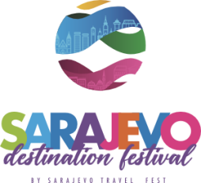 | Sarajevo Destination Festival  BY SARAJEVO TRAVEL FEST  25. - 27. APRIL 2024.  CENTAR SKENDERIJA SARAJEVO

Closing date: 25.03.2024.

APPLICATION FOR PARTICIPATION

FILLED UP BY PARTICIPANT:
1. Participant / Name of company: _______________________________________________________________________________________________
ID number: ___________________________ VAT number. ___________________________ Account number: ___________________________
Address: _______________________________________________________________________________________________________
Street Zip code City Country
____________________________________________________________________________________________________________
phone fax mobile e-mail web

2. Authorized person/Contact person: _______________________________ phone: _____________________ e-mail: _________________________

3. We hereby apply for following:

Code | Service | Measurement | We order
0001 | Space 9 m² (walls, carpet, desk, table, 4 chairs, fascia)  Visibility of your company in the festival brochure, through the social media and web site  Time slot on the main stage for the presentation of your destination – 30 min.  Specialized workshops - 2 hours  Badges - 4 pcs  Parking ticket - 1 pcs  Sarajevo sightseeing tour - 2 persons  Concert tickets of the group "Divanhana" - 2 persons | pcs | _________________

We are interested in organizing a raffle during participation in the Festival and awarding the following prizes:
- _______________________________________
- _______________________________________
- _______________________________________

A special promotion is provided for participants who will organize a raffle and provide prizes.

____________________________________ _________________________________
City and date Stamp and signature of Participant

All application materials have to be filled out, signed and stamped, otherwise your application will not be accepted.

