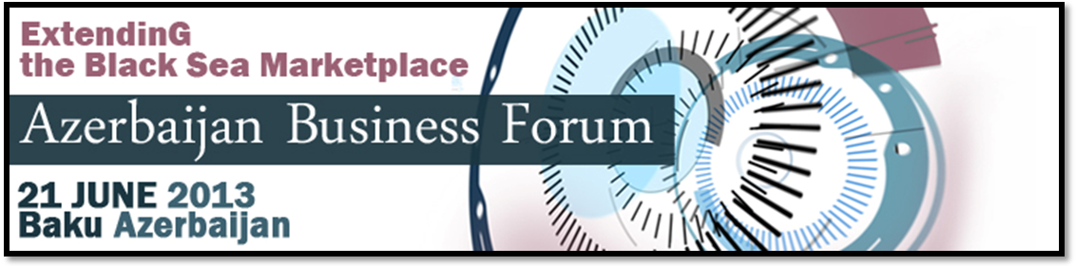
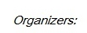
Company Name:

Applicant Information
Surname :

First Name :
Street Address:
Town/City |  |  |  | Country:
Phone No:

Email:
Website:

Short company PROFILE
Year of establishment: |  |  |  |  | Number of employees:
Annual turnover
Cooperating with the following countries:

Sector(s) Of Activity (please indicate):
Agriculture : |  |  |  |  |  |  |  |  | Logistics/Transport:
Construction: |  |  |  |  |  |  |  |  | IT/Consulting:
Tourism: |  |  |  |  |  |  |  |  | Packaging:
Other|(please indicate):
Brief Description Of the Company:

Description of the potential partner :

Interested to have a meeting with a banker from the Black Sea Trade and Development Bank to discuss financing options (See www.bstdb.org) |  |  |  |  |  |  |  |  |  |  |  | other development bank  (please indicate)___________________


