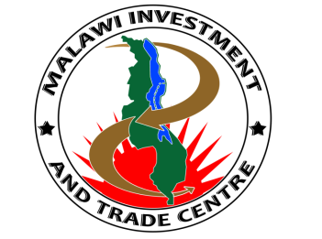

MITC Form 2
THE MALAWI INVESTMENT FORUM (MIF 2015)
EXHIBITOR REGISTRATION FORM
29-30th JUNE 2015, Lilongwe, Malawi
Please complete and return, via email or fax, no later than Tuesday, 9th June 2015
Telephone +2651770800/Fax +2651771781
Email: ceo@mitc.mw, web: www.mitc.mw

Please send one registration form for your entire organisation

Exhibitor Details

Organization

Address

City

Phone/ Email

Contact Person/ Designation

Product Description
Please provide a brief description of your product (50 words or less)

_________________________________________________________________________________________________________________________________________________________________________________________________________________________________________________________________________________________________________________________________________________________________________________________________________________________________________

Name, Telephone and email of your onsite Representative
____________________________________________________________________________________________________________________________________________________________________________________________________________________________________________________________________________________________________________________________________________________
TOTAL AMOUNT ENCLOSED
Payment in full by cheque, or cash should be included with this registration form. Deposit can also be made to MITC Bank Account details. The documents can be scanned and sent to +2651771781 or emailed to ceo@mitc.mw
Name: MITC-Investment and Trade Fees
Bank: National Bank of Malawi
Branch: Capital City Branch
Account Type : Current Account
Bank Account: 1000298804

FOR OFFICIAL USE
Invoice Number:
Payment Date Received:
Administered by:
Signed off by:

