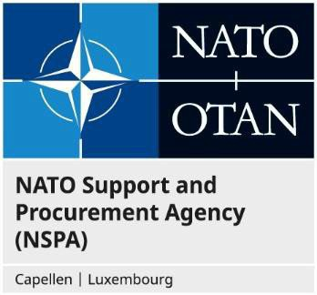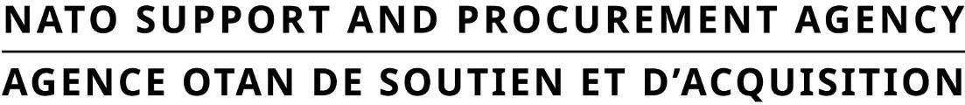
Night Vision Surveillance Equipment (NVSE) Conference/Industry Day
Questionnaire for Industry

In order to better track all questionnaires, it would be appreciated if you would indicate in each submittal the following information: Noted that this event is only for original equipment manufacturers (OEM)

Company or Organization Name:
Address (legal address, site of effective administration, or main production):
Country of incorporation/registration:
Cage Code (if available):
Company web site:

Point of contact: Industry participation in this event will only be by invitation upon verification of the scope and audience criteria set forth.
Last/First name:
Email address:
Telephone:

Please indicate below which type of equipment you would like to present at this event.

Products Name
Function / Specification
Where it’s manufactured

Important: Without the above and Product Data sheet, NSPA will not be able to confirm or not the participations of companies.

