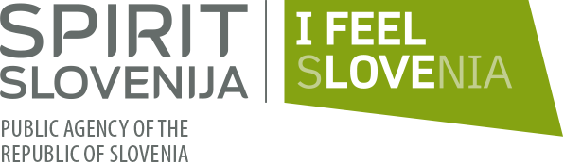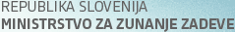
REGISTRATION FORM
"SLOVENE BUSINESS DELEGATION"
16+1 B2B MATCHMAKING EVENT and PANEL DISCUSSIONS
Hotel Rixos Libertas Dubrovnik, Liechtensteinov put 3, Dubrovnik
April 12th, 2019
Company name (in English):
TAX Number:
Incorporation date (date of establishment):
Country:
City:
Street and postal code:
Name of contact person:
Telephone:
E-mail :
Company Website:
Industry of the enterprise (sector):
Main Product/Service:
Number of staff:
Sales income of previous year:
Total assets of previous year:
Short introduction of the company (max. 700 characters):
Detailed Intention of Cooperation (selling / buying /JV/ inward or outward investment
Do you wish to participate in the B2B meetings?
PANEL 1 | Inovacije in industrija
PANEL 2 | Inovacije za kreativne in turistično industrijo
PANEL 3 | Investicije & infrastruktura
PANEL 4 | Izvoz: Trgovina ob robu digitalizacije

