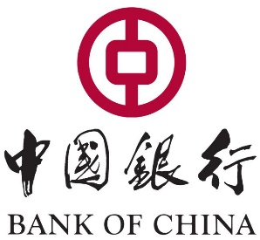
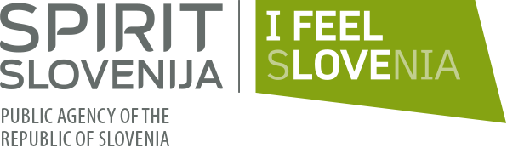
REGISTRATION FORM
"SLOVENE BUSINESS DELEGATION"
16+1 B2B MATCHMAKING EVENT and PANEL DISCUSSIONS
Papp László Budapest Sportaréna (1143 Budapest, Stefánia street 2.)
November 27th, 2017
Company name (in English):
TAX Number:
Incorporation date (date of establishment):
Country:
City:
Street and postal code:
Name of contact person:
Telephone:
E-mail :
Company Website:
Industry of the enterprise (sector):
Main Product/Service:
Number of staff:
Sales income of previous year:
Total assets of previous year:
Short introduction of the company (max. 700 characters):
Detailed Intention of Cooperation (selling / buying /JV/ inward or outward investment
Do you wish to participate in the B2B meetings?
SUBFORUM PART A: In which panel you would like to participate | - E-commerce, logistic and custom forum  - Finance forum  - Do not wish to participate
SUBFORUM PART B: In which panel you would like to participate | - Agricultural and environmental technology, water management panel  - Small and Medium Enterprise pane  - Do not wish to participate

