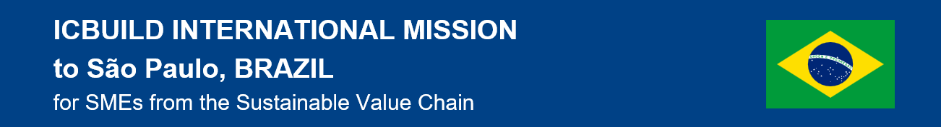
GOOO GREEN Brazil, EU-Brazil business conference and networking event
Date: 4 April 2024 / Venue: CTE - Centro de Tecnologia de Edificações (Building Technology Center), Rua Pascoal Pais, 525 - 13º andar Brooklin ǀ São Paulo – SP

Registration form for conference and networking event

1. I wish to participate in the B2B meetings YES/NO
2. I will participate in the visit to Parque Global YES/NO

Complete your profile
Add information about you and your organisation to your profile.
It is extremely important to insert relevant information, to help our in-market partners find the right counterparts during the B2B events, and all participants can get a better understanding of what you are looking for and can offer.
This information will be also used in the B2B meetings

Company Description
Name of the Company
Company size |  SME (small and medium company)  Large
Name and Surname of company representative
Position in the company
Address of the company
City
Phone
Email
Website
Please provide links/handles to social media accounts (if applicable)
Areas of Activity
Business type |  Manufacturer  Service Provider  Trader   Other(specify):
Company profile | Provide a one-paragraph description
Describe in detail your company’s products/services and along with an explanation of how they are used
Promotional material** (photo, links to relevant contents, other)
Indicate your business objectives for this mission
Please describe your experience (if any) in Brazil and let us know if you already have a local agent or Exports representative
Co-operation proposed on |  Products, services (Exports, Imports, Technology transfer)   Partnership (Sales office representation   Project cooperation (Research & Development, Staff exchange, )   Investment (Joint venture, Merger and Acquisition, Foreign Direct Investment(s) (FDIs)   Expertise (Knowledge sharing & information exchange, Organisation of joint business events, Soft Landing services)  You can select one or more items
For each of the above selected opportunities, please describe more in detail the kind of cooperation you are offering or searching.
Try to be as clear and detailed as possible, so that potential partners can better understand what you are proposing.
Type or partner sought |  Importer   Distributor   Agent   Service provider   Local partner   Project partner   Investment partner  Other-describe: ____________________________________________________
For each of the above selected potential partners, please describe more in detail the key elements of your ideal partner.

Please describe your experience (if any) in Brazil and let us know if you already have a local agent or representative

Please send this registration form to vladimir.gumilar@sgg.si not later than 30.3.2023. If interested in B2B meetings, send this registration ASAP to arrange the meetings.

Participation is free of charge.

Data protection notice: The personal information provided will be used by event organizers to manage the event and B2B meetings. It will not be shared with any third party. Anonymized data will be used for reporting purposes of the ICBUILD EU project.

Short for 'Goooooooooooooal'', “scoring” green in Brazil

