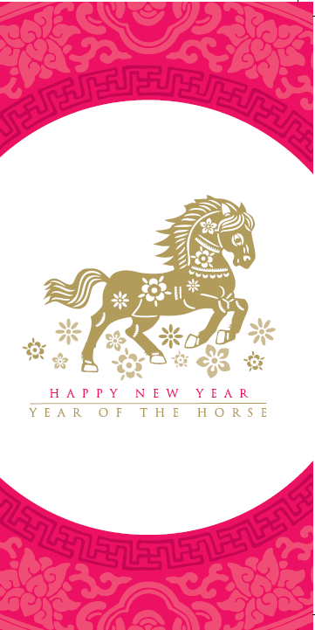 | 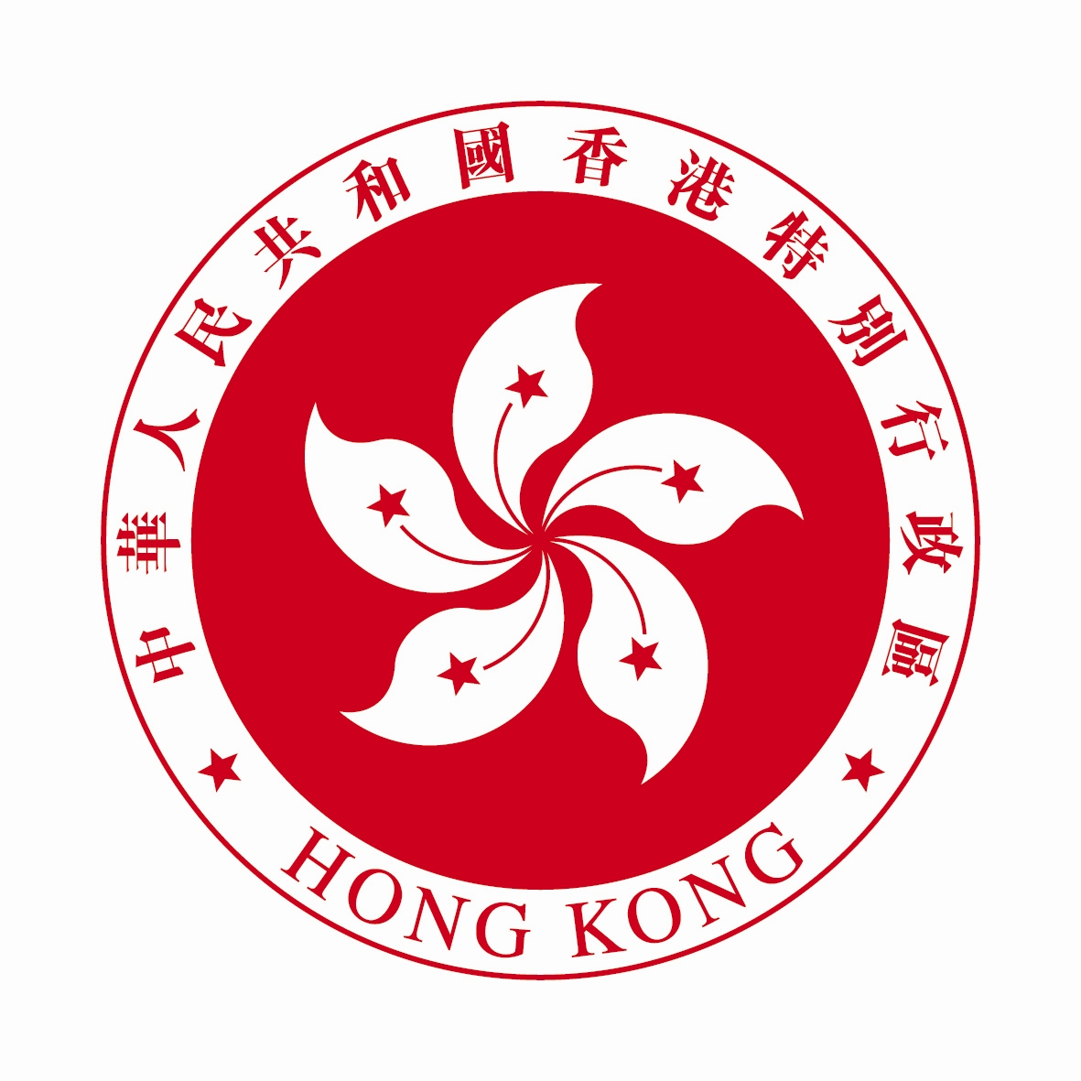  Mr Ivan K B Lee  Director, Hong Kong Economic and Trade Affairs (Central and Eastern Europe)  The Government of the Hong Kong Special Administrative Region  and  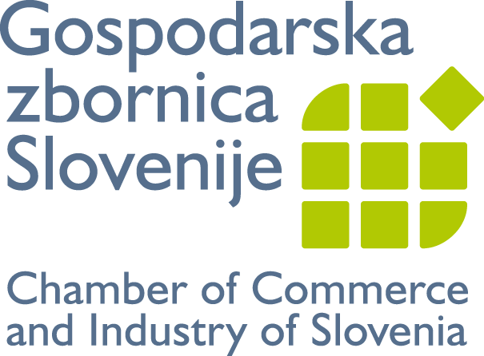  Mr Samo Hribar Milič  President  Chamber of Commerce and Industry of Slovenia  request the pleasure of your company  at a buffet reception  on the occasion of  the Chinese New Year of the Horse  at 12 noon  on Wednesday, 26 February 2014  at  Chamber of Commerce and Industry of Slovenia  Dimičeva 13, Ljubljana | Programme  12:30 Registration  13:00 Welcome Remarks  13:20 Musical Performance  13:40 Buffet Reception  14:30 End of Reception  Dress code: Business attire  RSVP by Tuesday, 17 February 2014 to http://www.gzs.si/slo/skupne_naloge/mednarodno_poslovanje/63830 or to  CEMP@gzs.si (Email)

